WORKSHOP REPORT
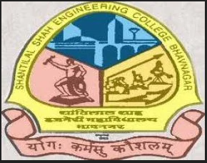 | 

A workshop on “Innovate & Insulate: The IPR and Patent Strategy Workshop” was conducted under SSIP 2.0 at Shantilal Shah Engineering College, Bhavnagar on 24th March 2026. The workshop was delivered by Prof. N. P. Soni.
The session focused on the importance of Intellectual Property Rights (IPR) and effective patent strategies for protecting innovative ideas and technologies. Students were introduced to concepts such as patents, copyrights, trademarks, innovation management, and strategic approaches for safeguarding inventions in competitive industries.
A total of 150 students actively participated in the event. The workshop encouraged students to think creatively, develop innovative ideas, and understand the importance of legal protection for intellectual assets.
Event Details

Particular | Details
Event Name | Innovate & Insulate: The IPR and Patent Strategy Workshop
Organized Under | SSIP 2.0
Venue | Shantilal Shah Engineering College, Bhavnagar
Date | 24 March 2026
Speaker | Prof. N. P. Soni
Total Participation | 150 Students

Event Photographs
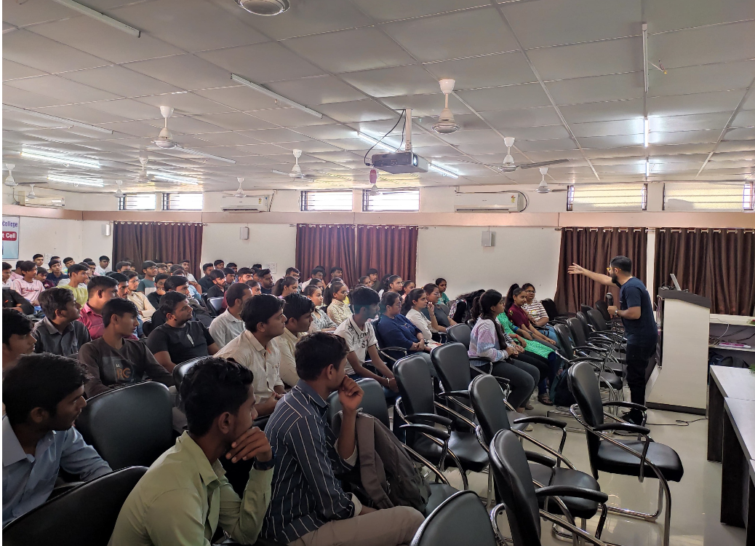
- Workshop session conducted under SSIP 2.0 on IPR and patent strategy.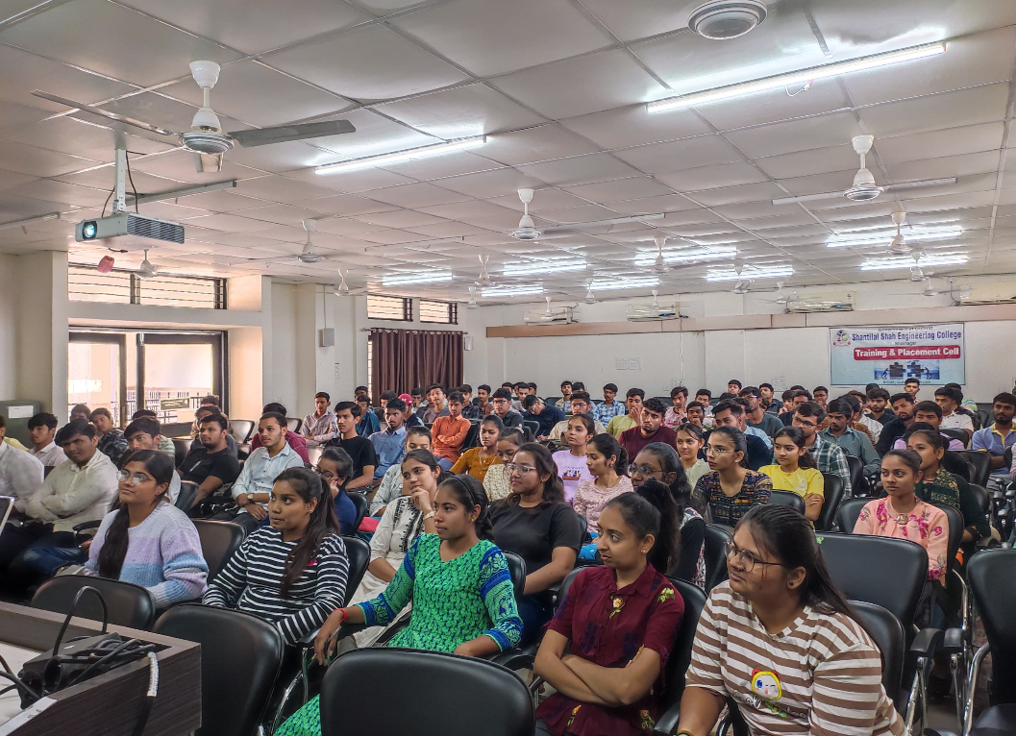
- Students participating actively during the workshop.

Conclusion
The workshop successfully created awareness among students regarding Intellectual Property Rights and patent strategies. It motivated participants to protect their innovations effectively and inspired them towards research, creativity, and entrepreneurship.

